5/10/2021

EROL A’NIL, Nathan Tai, Blake Topham

South Metropolitan TAFE

Movie Database Project

RAD Project - Team Elite

# Contents

Contents i

Figures iii

Tables iii

Source Control Screenshot 1

Analysis Report 1

Introduction: 1

CITE business rules for software development: 1

CITE Managed Services Quality Assurance: 2

Full-cycle QA Testing. 2

Document and Code Reviews 2

Defect Tracking 2

Configuration Management 2

Process Monitoring 2

Risk Management 2

Acme Entertainment Pty Ltd development requirements: 3

Create a working prototype of a movie database and webpage frontend. 3

Create a multi-platform report to determine if we should use an adaptive or responsive approach for multi-platform support. 3

Implement the chosen approach into the prototype. 3

Adaptive Design 2

Description 2

Advantages 2

Disadvantages 2

Responsive Design 2

Description 2

Advantages 2

Disadvantages 2

Project Selection 3

Software Testing Plan 4

Introduction 4

Scope 4

In Scope 4

Out of Scope 4

Quality Objective 5

Objectives 5

CITE MS QA Standards 5

Roles and Responsibilities 6

Scrum Master 6

Configuration Manager 6

Developer 6

Test Methodology 6

Overview 6

Test Levels 6

Test Tables 7

Screenshots 9

Bug Triage 1 14

Suspension Criteria and Resumption Requirements 15

Test Completeness 15

Test Deliverables 15

Resource and Environment Needs 16

Testing Tools 16

Test Environment 16

Glossary 16

# Figures

Figure 1- GitHub Screenshot 1

Figure 2- GANTT Chart 1

Figure 3- GANTT Chart (continued) 2

Figure 4- Test Case 1 failed 9

Figure 5- Name search 9

Figure 6- Name, Genre 9

Figure 7-Name, Genre, Rating 10

Figure 8- Name, Genre, Rating, Year 10

Figure 9- Top ten 11

Figure 10- Runs on PC 11

Figure 11- Runs on iPad 12

Figure 12- Runs on Galaxy S9 13

# Tables

Table 1- Bug Report 27/05/2021 14

Table 2- Timeline of Test Deliverables 15

Sprint One

Sprint Two

# Source Control Screenshot

Link: <https://github.com/profiteroles/RAD>

Screenshot:

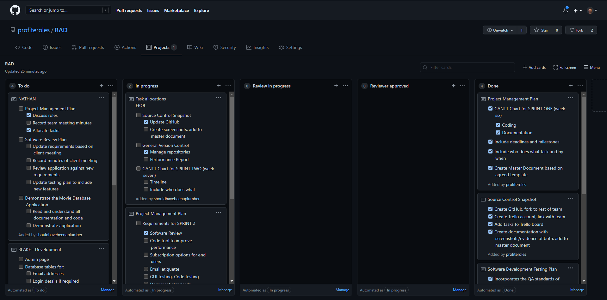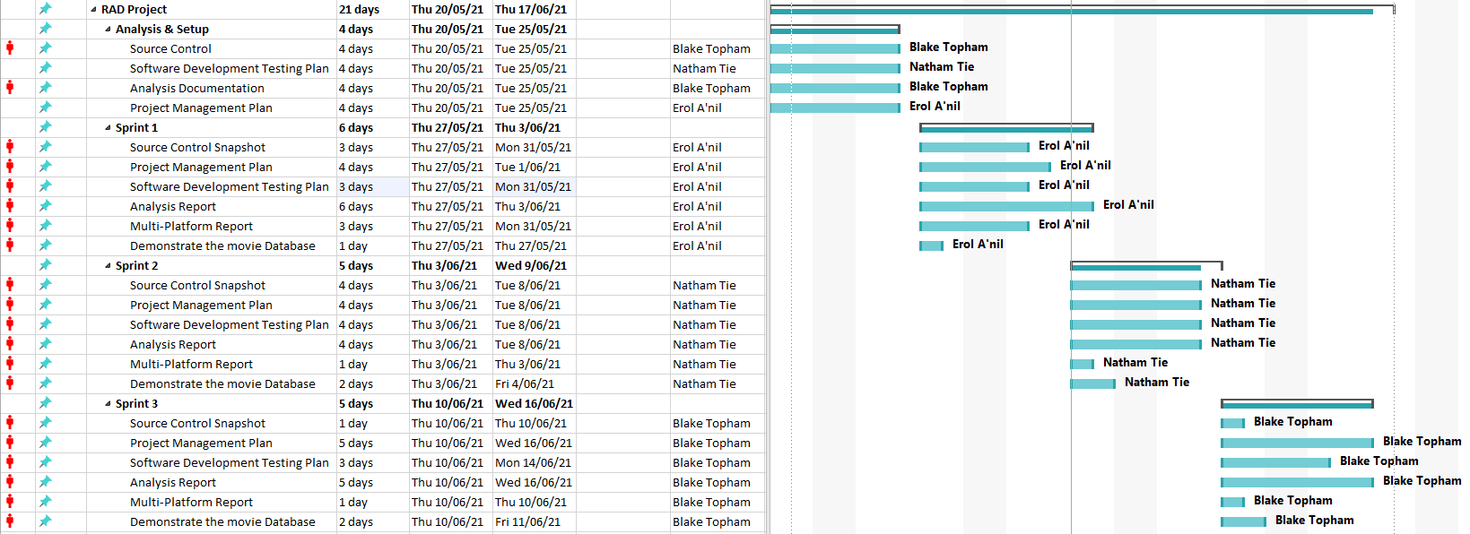

### Team Meeting

#### Meeting Minutes

03/06/2021

Present: Blake Topham, Erol Anil, Nathan Tai

Next meeting: 10/06/2021, 9:00AM, Murdoch Campus

**Erol: Source Control Snapshot**

* Update GitHub
* Create screenshots, add to master document

**General Version Control**

* Manage repositories

**GANTT Chart for SPRINT TWO (week seven)**

* Timeline
* Include who does what

**BLAKE Development**

* Admin page
* Database tables for:
  + Email addresses
  + Login details if required
* Unsubscribe feature
  + Sends email to admin account
  + Do not allow user to directly manipulate database
  + Admin account required to remove database entries
* Checkbox options for user to select:
  + Monthly newsletter
  + Newsflash notification email

**NATHAN: Project Management Plan**

* Discuss roles
* Record team meeting minutes
* Allocate tasks

**Software Review Plan**

* Update requirements based on client meeting
* Record minutes of client meeting
* Review application against new requirements
* Update testing plan to include new features

**Demonstrate the Movie Database Application**

* Read and understand all documentation and code
* Demonstrate application

# Performance Report

### Definition

Performance report is a documented assessment of performance and capacity of an application or system that is complex, time consuming and expensive to build. Performance test helps to reduce the risk of down time on multi-user interface by conducting tests that use “load” to reveal errors and limitations in the application.

The steps in a performance test are:

* Discovery
* Modelling
* Developing Scripts
* Execution of tests

### Goal

1. To clarify metrics and factors that the pages operate on
2. State of assumptions
3. Process description
4. Improvement opportunities

### Assumptions

These assumptions should be revised by the team closely related to the business and specific part of the application.

Software and Hardware

* CPU
* Network Connection
* Hard Drive
* Memory
* Version of Operating System
* Version of Software
  + Web Server
  + Database
  + Applications Server

### Process Description

All the steps in performance testing matter in making good decisions to make a project successful. These steps include, but aren’t limited to:

* Discovery
* Modelling
* Developing Scripts
* Executing Test

## Data Need Analysis

Load testing tools have graphic capability. Graphs are just tools but not an actual report, however graphical data aids visualization to guide the stakeholders in consuming actionable information. Learning pattern recognition can take years to acquire where the need exists to recognize the system performance changes after certain load is surpassed, understanding of the limiting resources etc, is an ongoing and changing process.

A performance tester does the following duties:

* Form hypothesis
* Draw tentative conclusions
* Collect information to determine the information needed for the above
* Prepare key visualizations that provide insight into the performance and bottlenecks
* Support report narratives

To perform the above duties a thorough understanding of the following is very important:

* Architecture
* Hard and Soft Resources
* Garbage Collection Algorithms
* Database Performance
* Message Bus Characteristics
* Auxiliary Components of Systems – in complex systems

The full value of the performance test is unlocked when there is collective information from Developers, Operations, database analysts, help desk techs, business stakeholders and all teammates. Few effective steps to successfully achieve this are:

* Collecting

To weigh up the validity of the performance results its essential to gather-

* + Errors and type of errors
  + Pattern of errors
  + Obtaining error logs from the application

Measurements from every few seconds helps to understand the granularity of the application and help us to spot the trends and transient conditions in application development and testing.

* Aggregating

Measurements with statistics like scatter plots, graphs, data ranges, variance studies to study the data distribution aids in making the report more accurate. Using various levels of granularity provide isolated to collective views of the performance with compared with consistent granularities. This can be an improvement strategy standard.

* Visualizing

Comparison studies are done by using key graphical indicators to help us understand what is happening during the testing of the application.

List of the comparative visualizations are

* Check for validity of results by studying **Load data vs Error**
* Recognizing bottlenecks by checking **Load vs bandwidth throughput**
* Study scaling and scaling behavior by studying **Load vs Response time**
* **Capacity of Infrastructure** i.e.system resources adequacy is determined by
  + Load vs Server CPU
  + JVM heap Memory
  + Input/output latency
  + Database lock contention
* Interpreting

Evaluating the data and drawing conclusions from hypothesis can be done by

* Quantitative observations – What can be mainly observed in the data?
* Comparing the observations – Where are the consistencies and inconsistencies?
* Developing hypothesis based on observations
* Testing the hypothesis
* Conclude from the hypothesis by validating
* Analysing

Deciding on actions to be taken by checking if the objectives are met, then determining remediation options at business level, applications level, system requirements and network level, then retest.

Transparency in costs, benefits, and risk is essential, them must be specific and actionable at technical level or at the management level.

* Reporting

This is done by aggregating and presenting the risks, costs, limitations and recommendations to the stakeholders’ terms in a short elevator summary or a brief narrative. The report has the following sections:

* Executive summary
* Supporting detail
* Documents associated with the test
* Presentation

## Performance of Results

Response that we get within 65ms.

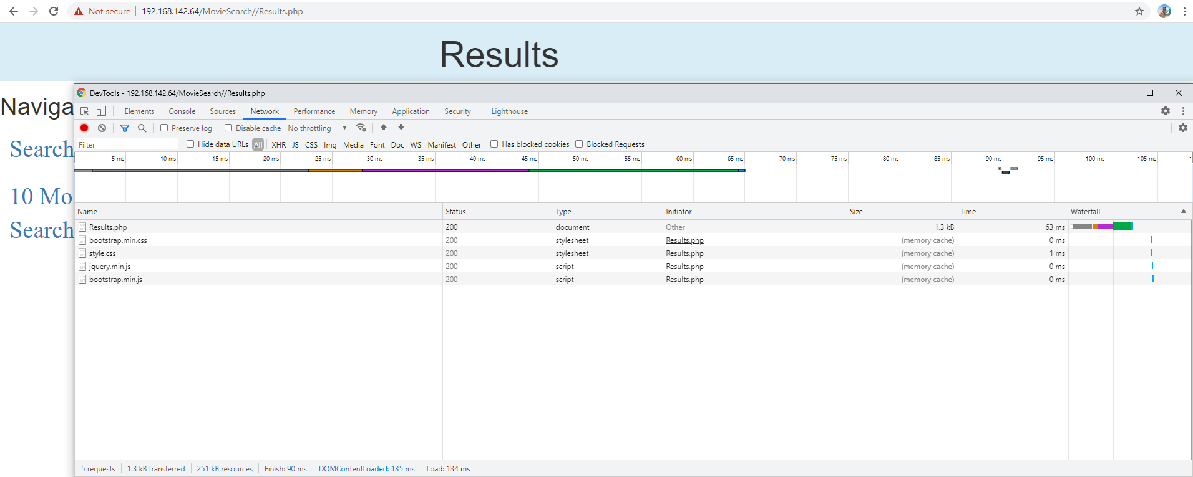

## Performance of Top 10 Movies

The completion of top 10 movies takes up to 980ms which includes the loading of a graphical chart.

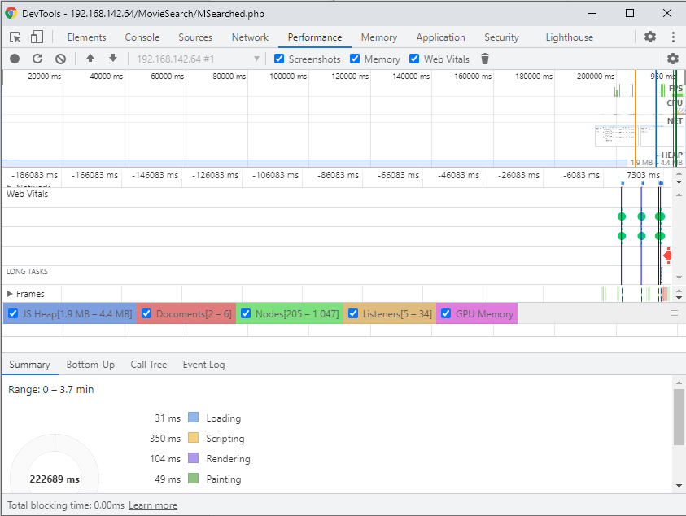

## Performance of Home Page

The Home(Index) page loads less than 50ms.

